# Prob1

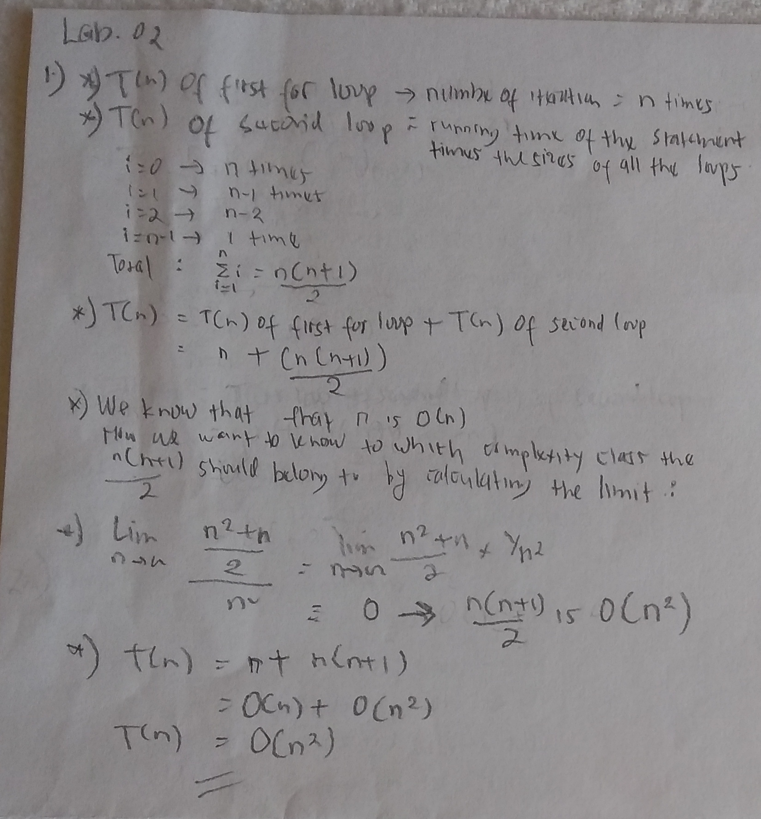

# Prob2

## 2A

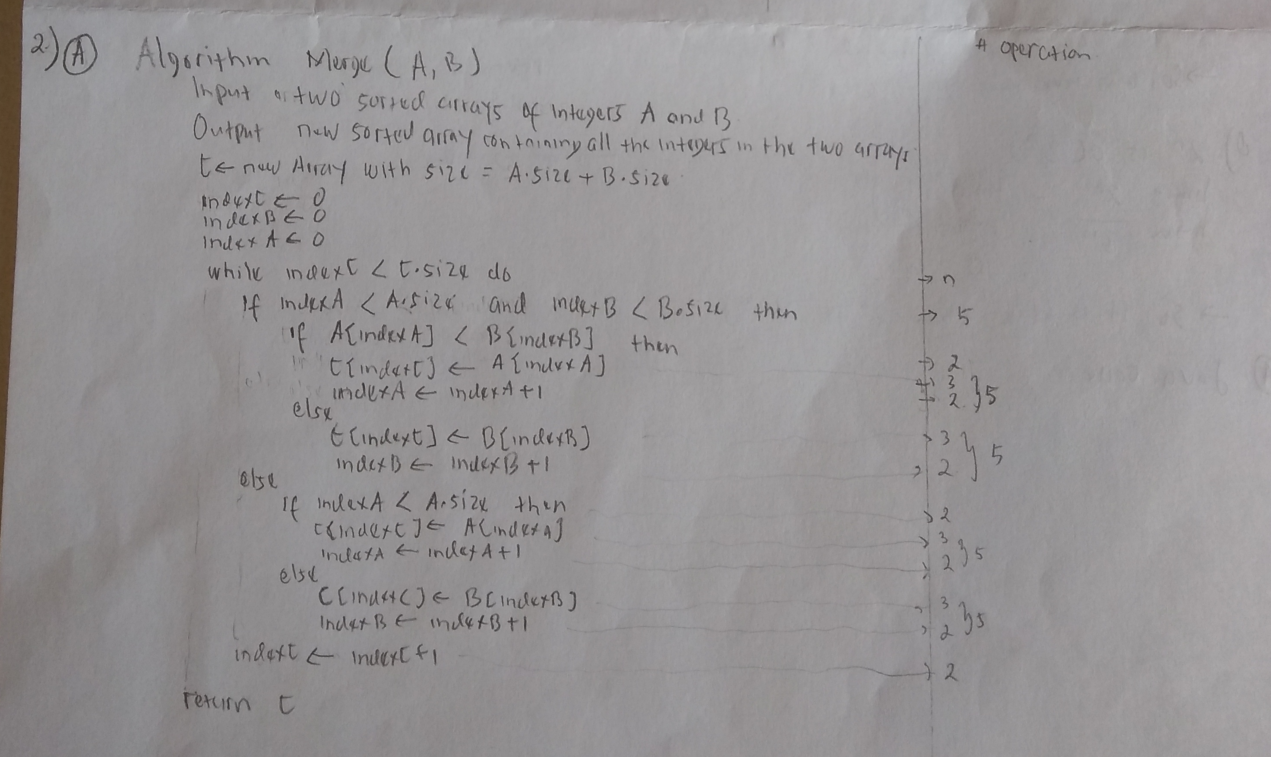

## 2B

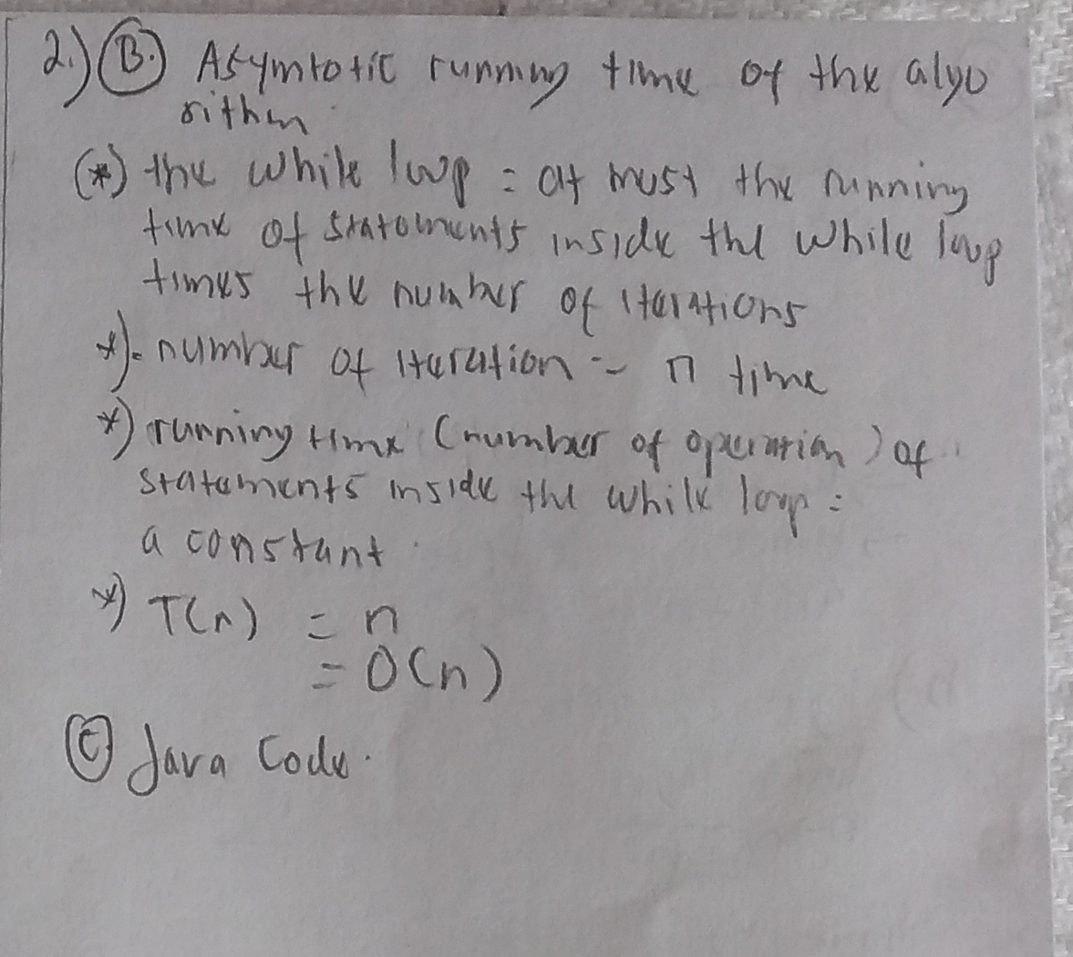

## 2C

**public** **static** **void** main(String[] args) {

**int**[] arr1 = {1,2,3,5,8,43,66,22,55};

**int**[] arr2 = {55, 3,7,99,12,31};

Arrays.*sort*(arr1);

Arrays.*sort*(arr2);

System.***out***.println("Arr1: "+Arrays.*toString*(arr1));

System.***out***.println("Arr2: "+Arrays.*toString*(arr2));

**int**[] arrMerge = *merge*(arr1, arr2);

System.***out***.println("ArrMerge: "+Arrays.*toString*(arrMerge));

/*

output:

Arr1: [1, 2, 3, 5, 8, 22, 43, 55, 66]

Arr2: [3, 7, 12, 31, 55, 99]

ArrMerge: [1, 2, 3, 3, 5, 7, 8, 12, 22, 31, 43, 55, 55, 66, 99]

*/

}

**public** **static** **int**[]merge(**int**[] arr1, **int**[] arr2){

**int**[] arrMerge = **new** **int**[arr1.length + arr2.length];

**int** index1 = 0;

**int** index2 = 0;

**int** indexMerge = 0;

**while**(indexMerge < arrMerge.length) {

**if**(index1 < arr1.length && index2 < arr2.length) {

**if**(arr1[index1] < arr2[index2]) {

arrMerge[indexMerge] = arr1[index1];

index1++;

}

**else** {

arrMerge[indexMerge] = arr2[index2];

index2++;

}

}

**else** {

**if**(index1 < arr1.length) {

arrMerge[indexMerge] = arr1[index1];

index1++;

}

**else** {

arrMerge[indexMerge] = arr2[index2];

index2++;

}

}

indexMerge ++;

}

**return** arrMerge;

}

# Prob3

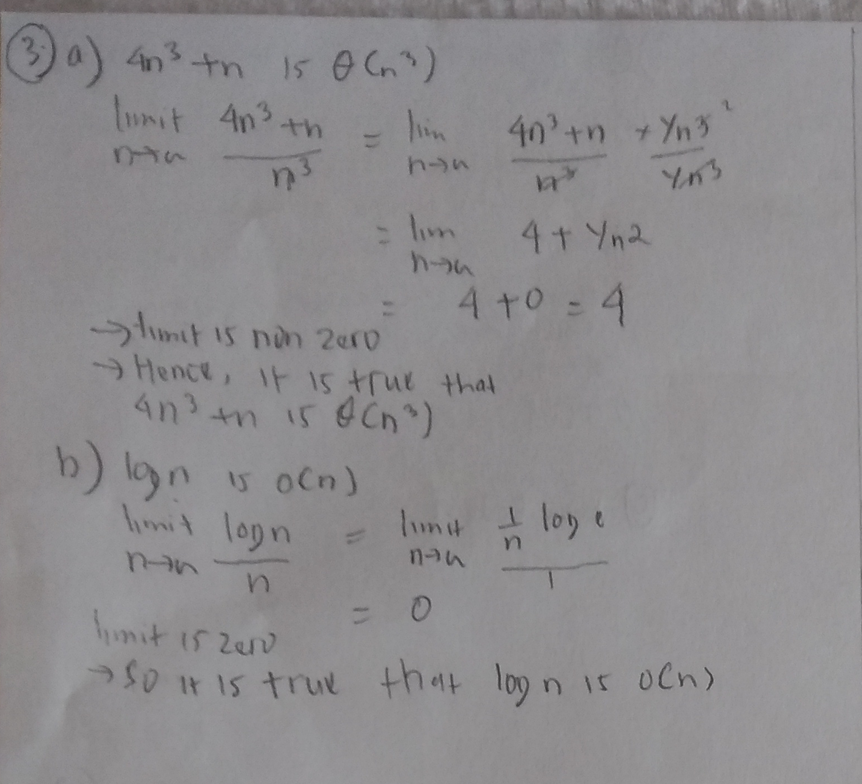

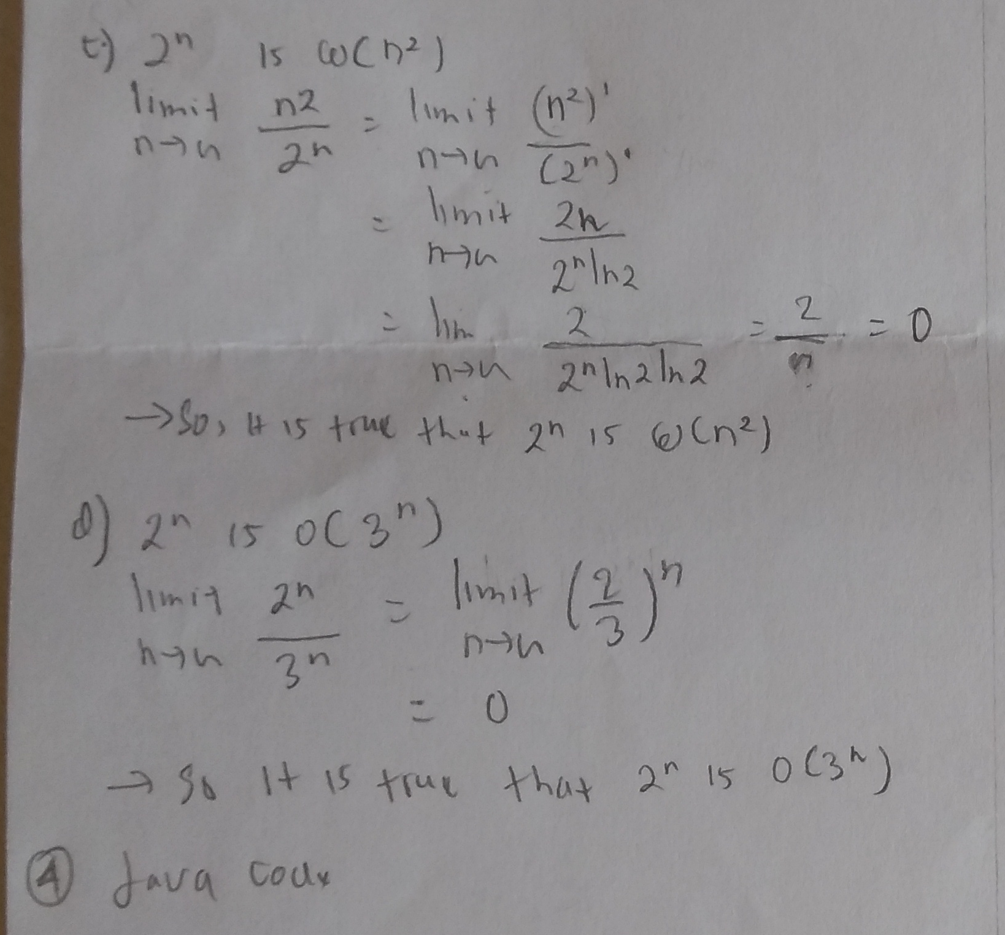

# Prob4

**public** **static** **void** main(String[] args) {

ArrayList<Integer> test = **new** ArrayList<Integer>();

test.add(1);

test.add(2);

test.add(3);

test.add(4);

test.add(5);

String input = test.toString();

List<Set<Integer>> powerSet = *powerSet*(test);

System.***out***.println("powerSet of "+input+" is "+powerSet.toString());

ArrayList<String> testStr = **new** ArrayList<String>();

testStr.add("titin");

testStr.add("farida");

testStr.add("cantik");

testStr.add("baik");

testStr.add("manis");

String inputStr = testStr.toString();

List<Set<String>> powerSetStr = *powerSet*(testStr);

System.***out***.println("powerSet of "+inputStr+" is "+powerSetStr.toString());

}

**public** **static** <T> List<Set<T>> powerSet(List<T> X) {

List<Set<T>> powerSet = **new** ArrayList<Set<T>>(); //P

Set<T> emptySet = **new** HashSet<T>(); //empty set //S

powerSet.add(emptySet);

**while**(!X.isEmpty()) {

T f = X.remove(0);

List<Set<T>> powerSetTemp = **new** ArrayList<Set<T>>();

powerSetTemp.addAll(powerSet); //cant use powerSetTemp = powerSet, maybe because it copied memory location (am I right??)

**for**(Set<T> arrInts : powerSetTemp) {

Set<T> newSet = **new** HashSet<T>(); //new set //T

newSet.addAll(arrInts); // cant use newSet = arrInts , maybe because it copied memory location (am I right??)

newSet.add(f);

powerSet.add(newSet);

}

}

**return** powerSet;

}

# Prob5

